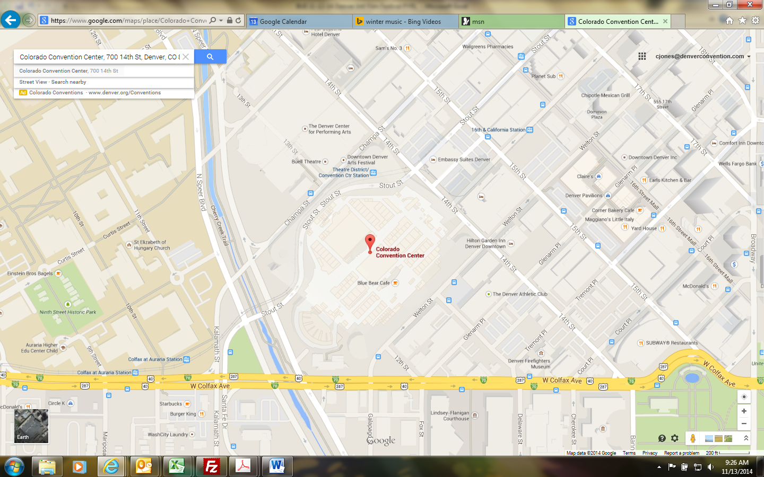

**Directions:**

**Security Base Check In – Mandatory**

700 14th Street

Denver, CO  80202

Take I-25 toward downtown Denver to the Speer Blvd Exit. Exit onto Speer Blvd (Exit 212) and head south. Follow Speer to Colfax Avenue. Turn left onto Colfax Ave heading east. At Welton St turn left. The Colorado Convention Center (CCC) is located on the left side of Welton St. Parking is available at parking meters, pay lots, etc.

**Crew Room/Area Directions**

After checking in with Security located near 12th St & Welton St, and buzzed into the CCC walk down the Operations corridor after exiting the double doors turn left.Walk through the 600’s cross corridor to the Grand concourse turn left and walk to the Bellco Theatre elevator. Once there take the elevator down to the Stage Level (SL), then turn right around the corner and in the left corner you will sign in with Cody Doss the Bellco Theatre House Lead.

Crew Room/Area Location

Cody Doss Office ice



Elevator ice