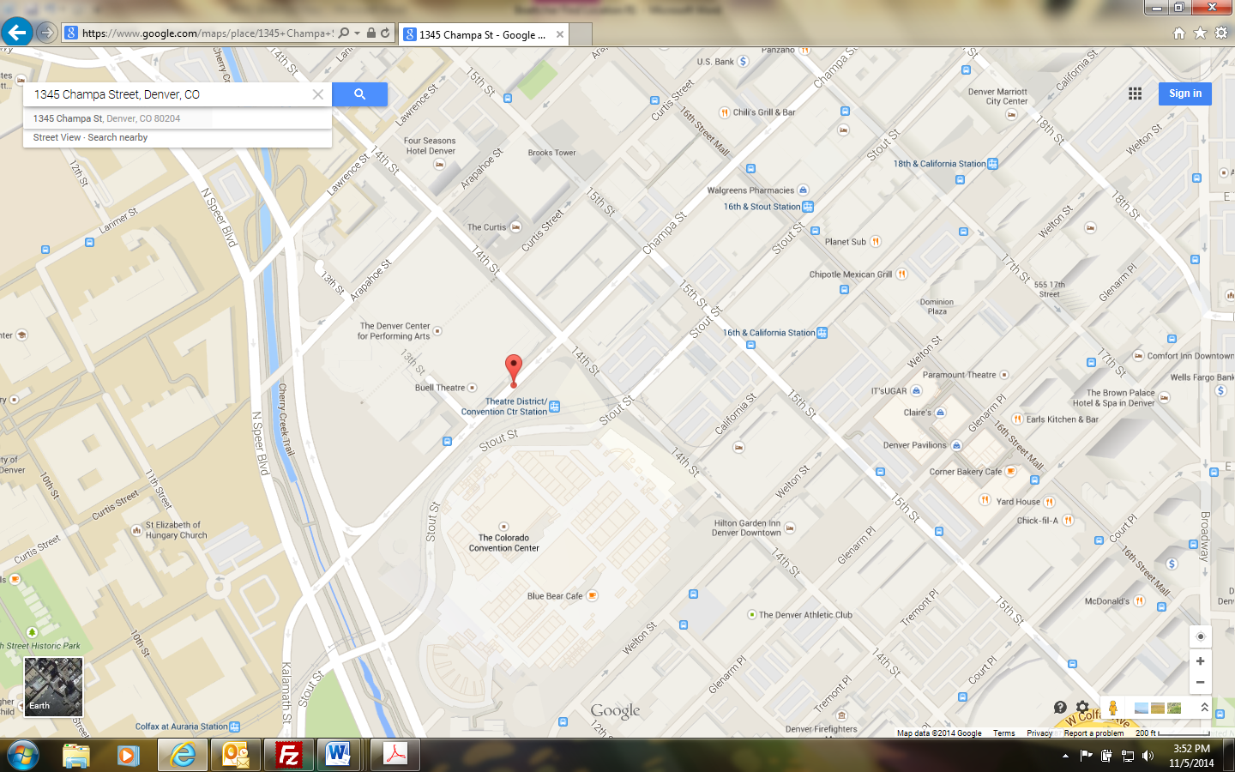

**Directions:**

**Security Base Check In - Mandatory**

1345 Champa Street

Denver, CO  80204

Take I-25 toward downtown Denver to the Speer Blvd Exit. Exit onto Speer Blvd (Exit 212) and head south. Follow Speer for approximately one mile to Arapahoe Street. Turn left onto Arapahoe St. Parking is available at parking meters, pay lots, etc.

**Crew Area/Room Directions:**

After checking in with Base located at 1345 Champa Street, the entrance to Boettcher is off of the corner of Champa Street & 13th Street. Go up the stairs on right before the loading dock. Once in the building take a left and walk up the hall the crew area/room is at the end.

Crew Area/Room Location

13th Street Entrance



Crew Area/Room