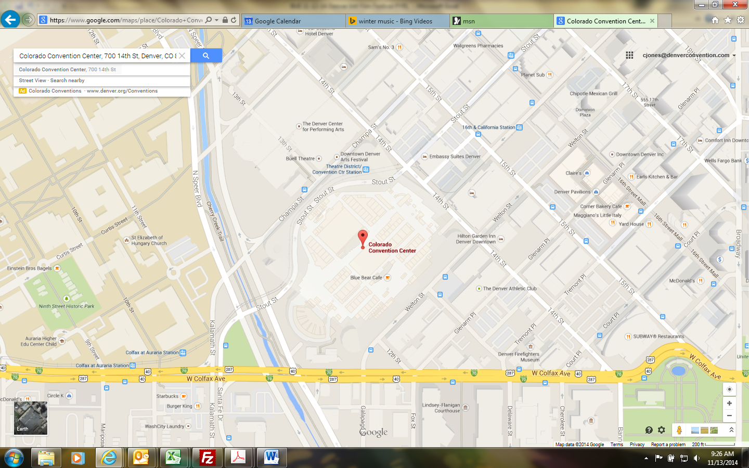

**Directions:**

**Security Base Check In – Mandatory**

700 14th Street

Denver, CO  80202

Take I-25 toward downtown Denver to the Speer Blvd Exit. Exit onto Speer Blvd (Exit 212) and head south. Follow Speer to Colfax Avenue. Turn left onto Colfax Ave heading east. At Welton St turn left. The CCC is located on the left side of Welton St. Parking is available at parking meters, pay lots, etc.

**Crew Room/Area Directions**

After checking in with Security located near 12th St & Welton St, and buzzed into the CCC walk down the Operations corridor and check in with Dave Clow Technical Services Supervisor located in the 6th office on the right side of the corridor.

Crew Room/Area Location



Dave Clows’ Office