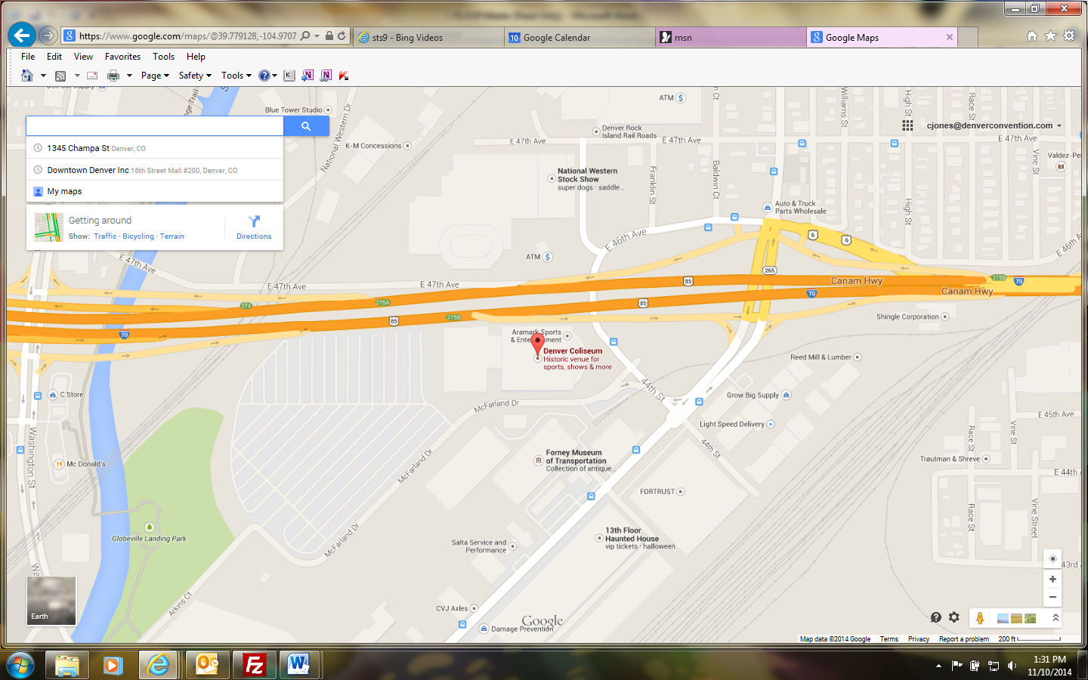

**Directions:**

4600 Humboldt Street   
Denver, CO 80216

Take I-25 N to Exit 214A for I-70 keep right at fork, follow signs for I-70 East toward Limon and Exit 275B for Bighton Blvd. keep right merge onto Brighton Blvd.Turn right onto 44th ave then follow under overpass.

Crew Room/Parking Directions:

**Crew Room/Office Location:**

Enter though double doors via the Stagehand Lot. Veer to the right and head back to the door labeled “Authorized Personnel Only”.



Stagehand Lot

SMG Office

Door 4

**Parking:**

Parking is located on the north side of the building by door one (1). Certain events will require staff to park in the stage hand lot.

N

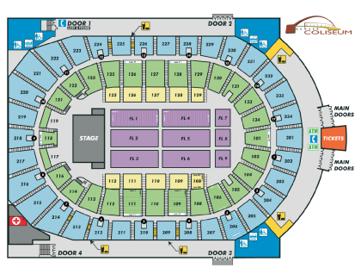

Door 1