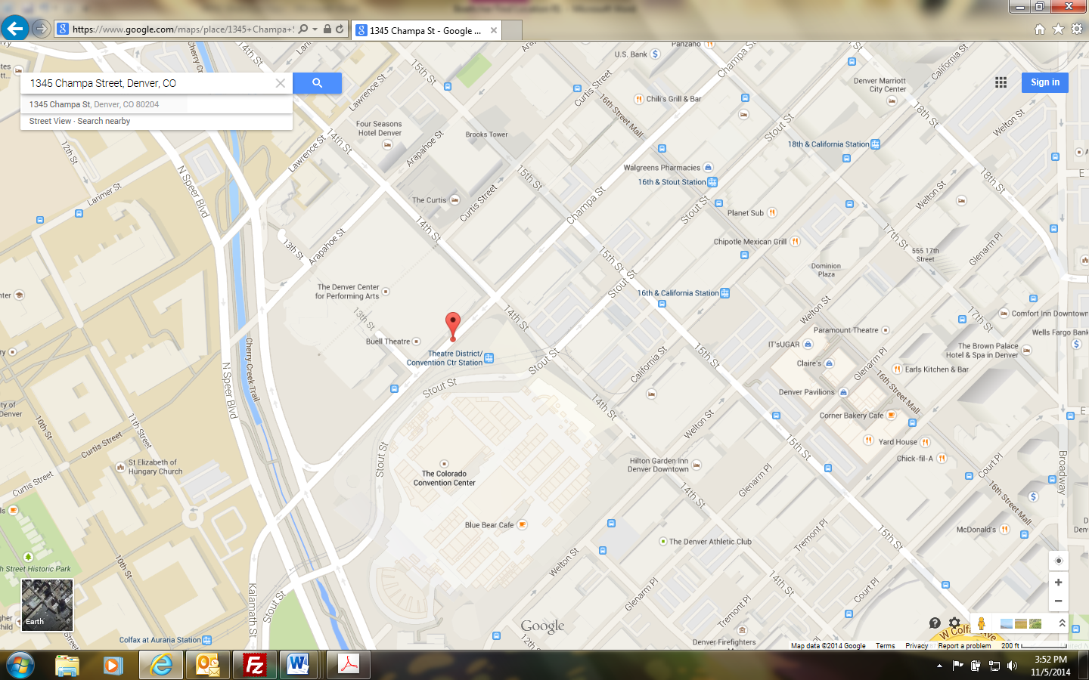

**Directions:**

**Security Base Check In - Mandatory**

1345 Champa Street

Denver, CO  80204

Take I-25 toward downtown Denver to the Speer Blvd Exit. Exit onto Speer Blvd (Exit 212) and head south. Follow Speer for approximately one mile to Arapahoe Street. Turn left on Arapahoe St. Parking is available at parking meters, pay lots, etc.

**Crew Room/Area Directions:**

After checking in with Base located at 1345 Champa Street, go through the double doors and take the elevator down to the Stage Level (“S” button). When exiting the elevator turn left, follow the hallway and take the first available right (after the vending machines). Follow the ramp down and through the door now you have entered the Ellie Caulkins Opera House. Turn left and then take an immediate right and follow the hall down to the Crew Room/Area.

Crew Area/Room Location



Door from Buell

Crew Room/Area