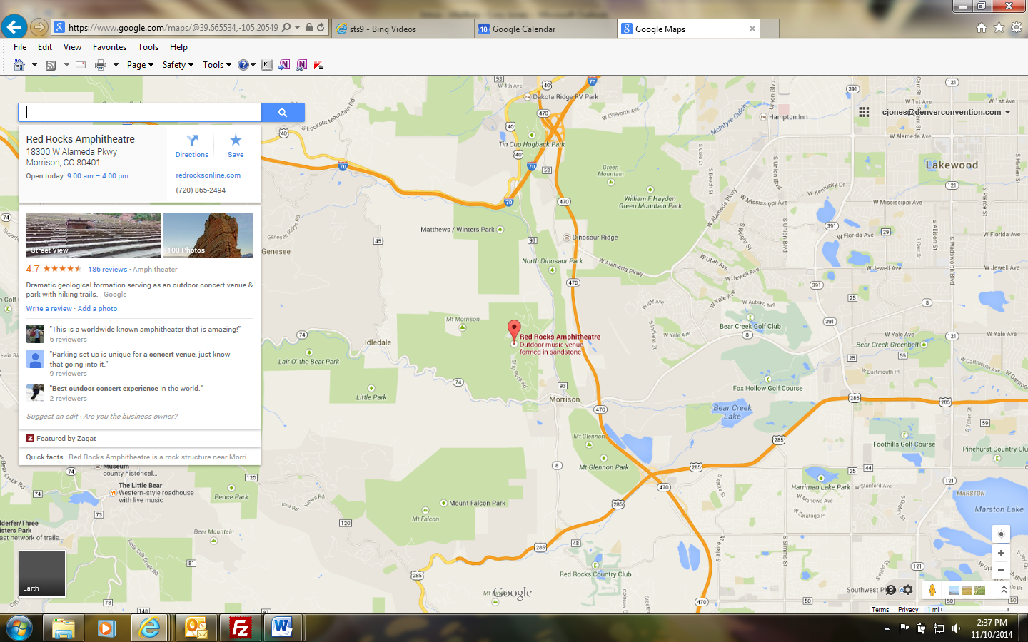

**Directions:**

Red Rocks near Morrison, 15 miles west of Denver. From Downtown, travel Hwy 1-70 or Hwy 6 to I-70 west to Morrison exit, #259. Turn left heading south at the bottom of the exit ramp onto Hwy 93 and continue to Red Rocks entrances.

**Parking/Crew Room Directions:**

Parking availability is directed by the event. Typical parking for working crew on the right hand side of Ship Rock Road called the Triangle Lot, and is on a first come basis. Climb the road up the hill that leads to the backstage lot (shuttle service is never guaranteed). Once at the backstage lot you may continue up the hill to the road leading up to the stage loading dock or towards the back of the backstage lot there is a gate that leads into Red Rocks, and follow the ramp all the way up to the stage. The crew office is located on the ground level of the North Tower stage right.

**SMG and Crew Office Location:**



Crew Office

SMG Production Office